**KINGSTON ENGINEERING COLLEGE-5113**

**ARTIFICIAL INTELLIGENCE - PHASE 5**

**TOPIC: PREDICTING HOUSE PRICES USING MACHINE LEARNING**

**TEAM MEMBERS:**

**V. EBONICA SALETH- au511321104025(**[**ebonicasalethvincent@gmail.com**](mailto:ebonicasalethvincent@gmail.com)**)**

**G. KANIMOZHI- au511321104040(** [**kanimozhigopal2004@gmail.com**](mailto:kanimozhigopal2004@gmail.com)**)**

**D. AKSHAYA- au511321104004(**[**Akshayadayalan03@gmail.com**](mailto:Akshayadayalan03@gmail.com)**)**

**K. INDUJA-**

**au511321104031(**[**indujaindu137@gmail.com**](mailto:indujaindu137@gmail.com)**)**

**PROJECT DOCUMENTATION**

**PROBLEM STATEMENT:**

The project aimed to address the critical task of predicting house prices using machine learning techniques. The primary objective was to develop a robust and accurate predictive model capable of estimating the selling prices of houses based on a variety of relevant features such as location, square footage, number of bedrooms and bathrooms, and other factors. The project underwent a meticulously structured process encompassing data exploration, preprocessing, feature selection, model training, and comprehensive performance evaluation.

**DATASET DESCRIPTION:**

This dataset is designed for the purpose of predicting house prices using machine learning. Each row in the dataset represents a different residential property or house. The dataset contains the following features:

* **Avg. Area Income:** This numerical feature represents the average income of residents in the area where each house is located. It provides insight into the economic status of the area.
* **Avg. Area House Age:** This numerical feature indicates the average age of houses in the area. It gives an idea of the age and condition of properties in the neighbourhood.
* **Avg. Area Number of Rooms:** This numerical feature shows the average number of rooms in houses within the area. It helps understand the size of houses.
* **Avg. Area Number of Bedrooms:** This numerical feature represents the average number of bedrooms in houses in the area. It provides information about the accommodation capacity.
* **Area Population:** This numerical feature reflects the population of the area where each house is situated. It can be indicative of the local community's size.

These features are used to predict the target variable:

* **Price:** The target variable is the price of each house. The goal of the machine learning task is to build a predictive model that can estimate house prices based on the provided features.

The dataset is a valuable resource for regression analysis and predictive modelling in the real estate domain, allowing for the development of machine learning models to make accurate house price predictions based on the given property characteristics. The "Address" column, while descriptive, may require further preprocessing or encoding if included in the modelling process.

**DESIGN THINKING PROCESS:**

1. **Problem Statement:**

* The problem was to predict house prices based on various features such as location, square footage, number of bedrooms and bathrooms, and other factors.
* The problem was defined as predicting house prices as accurately as possible.

1. **Data Acquisition and Understanding:**

* The necessary Python libraries for data analysis, visualization, and machine learning were imported.

1. **Data Collection:**

* We obtained our dataset from Kaggle. This dataset includes essential features such as location, square footage, number of bedrooms and bathrooms, and, most importantly, the house price. Having access to real-world data is essential for training a predictive model.
* **DATASET LINK:** [https://www.kaggle.com/datasets/vedavyasv/usa-housing](https://colab.research.google.com/corgiredirector?site=https%3A%2F%2Fwww.kaggle.com%2Fdatasets%2Fvedavyasv%2Fusa-housing)

1. **Data Exploration:**

* The dataset was loaded into a Pandas Data Frame.
* The data was explored to understand its structure and contents.
* The first and last few rows were displayed.
* Data types were checked.
* Missing values were identified.
* Summary statistics were calculated.
* The columns and shape of the dataset were examined.
* The data types of the columns were listed.
* The 21st row (index 20) was accessed.
* The number of unique values in each column was determined.

1. **Data Visualization:**

* A correlation heatmap was generated to visualize the relationships between features.
* A histogram of house prices was created to understand the distribution.
* Scatter plots were generated to explore the relationships between average area income, house age, number of rooms, population, and house prices.

1. **Data Preprocessing:**

* Feature selection was performed, excluding the 'Address' column.
* The dataset was split into training and testing sets for model training and evaluation.

1. **Data Preprocessing and Transformation:**

* Data was normalized using Min Max Scaler and Standard Scaler for feature scaling.
* Cross-validation was applied with different preprocessing methods and algorithms to assess model performance.

1. **Model Building:**

* A linear regression model was built and trained on the pre processed training data.
* A random forest regression model was created and trained on the training data.
* A gradient boosting regression model was developed and trained on the training data.
* A support vector regression model was implemented and trained on the training data.

1. **Model Evaluation:**

* Model performance was evaluated by calculating Mean Squared Error (MSE) and R-squared (R2) score for each model.
* Actual vs. predicted house prices were visualized using scatterplots.
* Feature importance was visualized for the Random Forest model.

1. **Conclusion:**

* This project underscored the significance of data preprocessing, feature selection, and model evaluation in constructing accurate predictive models. These models can offer invaluable support in making informed decisions in the real estate domain.

**PHASES OF DEVELOPMENT:**

**Phase 1: Problem Definition and Design Thinking**

In this phase, we aimed to understand the problem statement and create a clear plan for solving it. We started by comprehensively defining the problem and our approach.

**Problem Definition:**

We thoroughly analyzed the problem statement, which was to predict house prices based on several key features. The dataset, "USA_Housing", was provided for this task.

**Design Thinking:**

To solve this problem, we followed a structured design thinking process. We broke it down into the following steps:

* **Empathize:** We empathized with the problem by understanding the dataset and the features it contained.
* **Define:** We clearly defined the problem statement and our goal, which was to build a predictive model for house prices.
* **Ideate:** We brainstormed potential approaches, including innovative techniques and algorithms.
* **Prototype:** We created a plan for the project, outlining the phases of development.

**Phase 2: Innovation**

The innovation phase was a critical step in which we explored cutting-edge techniques to maximize the prediction system's accuracy and resilience. We delved into advanced regression methods, including Gradient Boosting and XG Boost, to enhance the predictive accuracy of our models. The integration of these advanced algorithms was a pivotal aspect of our project, aimed at pushing the boundaries of traditional regression analysis.

**Phase 3: Development Part 1**

This phase marked the inception of our house price prediction model. We initiated the journey by loading the dataset and diligently preparing it for subsequent stages. The pivotal steps involved in this phase were as follows:

* **Dataset Loading:**

We sourced the housing dataset from an external repository, ensuring that it provided comprehensive and relevant information.

* **Data Exploration:**

To gain an insightful understanding of the dataset, we conducted an exploratory data analysis. We inspected the initial and concluding rows of the dataset, assessed its overall structure, and scrutinized summary statistics. Moreover, we meticulously inspected the data for any missing values. An in-depth examination of the dataset's columns and their data types was carried out to understand the scope and nature of the data.

* **Specific Row Access:**

We went a step further to access a specific row (in this case, the 21st row) to analyze the dataset's granularity and integrity.

* **Unique Value Counts:**

We meticulously assessed the number of unique values in each column, providing detailed insight into the diversity and distribution of data within the dataset.

* **Preprocessing the Dataset:**

We also pre processed the dataset to prepare it for model training. We applied data scaling techniques, such as Min-Max scaling and Standard scaling, to standardize the feature values. Min-Max scaling transformed the data to a common scale, typically between 0 and 1, while Standard scaling standardized the data by centring it around the mean and scaling it to have a standard deviation of 1. These preprocessing steps were necessary to ensure that all features had equal influence on the models and to improve their convergence during training.

* **Cross-Validation:**

To further assess the performance of our models, we conducted cross-validation with different preprocessing methods and algorithms. Specifically, we used a 5-fold cross-validation strategy to train and validate our models multiple times with different subsets of the data. This helped us estimate how well our models would generalize to unseen data and provided a more robust evaluation of their performance.

**Phase 4: Development Part 2**

Building upon the groundwork laid in the previous phase, we continued the development process. This phase encompassed four fundamental activities:

**Data Visualization:**

* **Correlation Heatmap:**

We used a correlation heatmap to visualize the relationships between various features, helping us identify which features were most influential.

* **Histogram of House Prices:**

A histogram with a kernel density estimate revealed the distribution and patterns in house prices.

* **Scatter Plots:**

We created scatter plots to explore the relationships between house prices and key factors like average area income, house age, number of rooms, and population density. These plots provided a quick visual assessment of potential trends and outliers.

**Feature Selection:**

To enhance the quality of our models, we performed feature selection. In this process, we decided to exclude the 'Address' column from our dataset. We made this decision because 'Address' was not directly related to house prices and was, therefore, not considered a valuable feature for our predictive models. This careful feature selection process helped streamline our data and improve the overall performance of our models by focusing on the most relevant attributes.

**Model Training:**

We initiated the training of our prediction model. This was a pivotal stage where we harnessed the power of various machine learning algorithms, including Linear Regression, Random Forest, Gradient Boosting, and Support Vector Regression (SVR). Each of these algorithms played a crucial role in providing diverse perspectives on the data and delivering predictive models. Specifically, we have trained the models by fitting them to the training data using the historical features of houses, such as location, square footage, number of bedrooms and bathrooms. The algorithms were employed to learn the underlying patterns and relationships within the dataset.

**Performance Evaluation:**

After training each of these models, we rigorously evaluated their performance. For each model, we calculated Mean Squared Error (MSE) and R-squared (R2) scores to quantitatively assess their predictive accuracy and capability. These evaluation metrics allowed us to compare the performance of the different models and select the one that performed the best on our dataset. Additionally, we visualized the results by creating scatter plots, which allowed us to visualize the alignment between actual house prices and the predicted values. These plots helped us to identify any trends or discrepancies in the models' predictions.

**THE CHOICE OF REGRESSION ALGORITHM AND EVALUATION METRICS:**

**Choice of Regression Algorithm:**

**1. Linear Regression:**

When the relationship between the independent variables and the target variable appears to be approximately linear, linear regression is a straightforward choice. It’s a simple and interpretable model.

**2. Support Vector Regression:**

Support Vector Regression (SVR) is useful when having a clear margin of separation between different target values and want to find a hyperplane that fits as many data points as possible.

**3. Gradient Boosting Regressors:**

Algorithms like Gradient Boosting (e.g., XGBoost, LightGBM, or CatBoost) are powerful for complex regression tasks. They build ensembles of decision trees to capture nonlinear relationships.

**4. Random Forests:**

Random Forest, are useful when the relationship between features and the target variable is nonlinear. They can handle both numerical and categorical features.

**Choice of Evaluation Metrics:**

* **Mean Squared Error (MSE):**

MSE is the average of the squared differences between predicted and actual values. It punishes larger errors more than MAE (Mean Absolute Error) and is more sensitive to outliers.

* **R-squared (R²):**

R-squared measures the proportion of the variance in the target variable that can be explained by the model. A higher R² value indicates a better fit.

**PYTHON CODE WITH OUTPUT:**

AI_Phase5(EBONICA SALETH).ipynb

**Original file is located at:**

<https://colab.research.google.com/drive/1X0MoHvgBSluU8vsftIxUDcLsrix_NkZa?usp=sharing>

**IMPLEMENTATION DETAILS:**

**DATASET DETAILS:**

We will acquire our dataset from Kaggle, specifically the "USA Housing" dataset. This dataset will contain a wealth of information about houses in the USA, making it suitable for our predictive modeling task.

* **KAGGLE DATASET:**
* **LINK:** <https://www.kaggle.com/datasets/vedavyasv/usa-housing>
* Before uploading file (downloaded from Kaggle) in the Google Colab convert the zip file to csv file using online converter:
* [https://www.ezyzip.com/convert-zip-to-csv.html#](https://www.ezyzip.com/convert-zip-to-csv.html)
* Now download the csv file from the website and upload it in the Google Colab.

**Step 1: Importing Libraries**

The code begins by importing the necessary Python libraries for data manipulation, machine learning, and data visualization.

**CODE:**

import pandas as pd

from sklearn.model_selection import cross_val_score

from sklearn.linear_model import LinearRegression, Ridge

from sklearn.ensemble import RandomForestRegressor, GradientBoostingRegressor

from sklearn.svm import SVR

from sklearn.metrics import mean_squared_error, r2_score

import numpy as np

import matplotlib.pyplot as plt

import seaborn as sns

**Step 2: Loading the Given Dataset**

This code snippet uses Google Colab's file upload feature to allow the user to upload the dataset file, which is named "USA_Housing.csv."

**CODE:**

from google.colab import files

uploaded = files.upload()

**Step 3: Reading the Given Dataset**

This line reads the dataset from the uploaded CSV file into a pandas DataFrame named 'data'.

**CODE:**

data = pd.read_csv("USA_Housing.csv")

**Step 4: Data Exploration**

In this section, the code explores the dataset, providing various insights about it. These code snippets print the first few and last few rows, general information, summary statistics, missing values, columns, shape, data types, and access the 21st row of the dataset. It also calculates and prints the number of unique values in each column.

**CODE:**

print("First few rows of the dataset:")

print(data.head())

print("Last few rows of the dataset:")

print(data.tail())

print("Dataset Information:")

print(data.info())

print("\nSummary statistics:")

print(data.describe())

print("\nMissing Values:")

print(data.isnull().sum())

print("\nColumns:")

print(data.columns)

print("\nShape:")

print(data.shape)

print("\nDATA TYPES:")

print(data.dtypes)print("\nAccess the 21st row (index 20)")

data.iloc[20]

unique_counts = data.nunique()

print("Number of unique values in each column:")

print(unique_counts)

**Step 5: Data Visualization**

In this section, the code generates visualizations to explore the data. These code snippets create a correlation heatmap, a histogram of house prices, and multiple scatter plots to visualize the relationships between various features and house prices.

**CODE:**

**#Correlation Heatmap**

correlation_matrix = data.corr()

plt.figure(figsize=(10, 8))

sns.heatmap(correlation_matrix, annot=True, cmap="coolwarm")

plt.title("Correlation Heatmap")

plt.show()

**#Histogram of House Prices**

plt.figure(figsize=(8, 6))

sns.histplot(data['Price'], kde=True)

plt.xlabel("House Price")

plt.ylabel("Frequency")

plt.title("Histogram of House Prices")

plt.show()

**# Scatter plot of Avg. Area Income vs. Price**

sns.scatterplot(x='Avg. Area Income', y='Price', data=data)

plt.title("Price vs. Avg. Area Income")

plt.xlabel("Avg. Area Income")

plt.ylabel("Price")

plt.show()

**# Scatter plot of Avg. Area House Age vs. Price**

sns.scatterplot(x='Avg. Area House Age', y='Price', data=data)

plt.title("Price vs. Avg. Area House Age")

plt.xlabel("Avg. Area House Age")

plt.ylabel("Price")

plt.show()

**# Scatter plot of Avg. Area Number of Rooms vs. Price**

sns.scatterplot(x='Avg. Area Number of Rooms', y='Price', data=data)

plt.title("Price vs. Avg. Area Number of Rooms")

plt.xlabel("Avg. Area Number of Rooms")

plt.ylabel("Price")

plt.show()

**# Scatter plot of Area Population vs. Price**

sns.scatterplot(x='Area Population', y='Price', data=data)

plt.title("Price vs. Area Population")

plt.xlabel("Area Population")

plt.ylabel("Price")

plt.show()

**Step 6: Splitting the Dataset into Features (X) and Target Variable (y)**

This code snippet splits the dataset into feature columns ('X') and the target variable ('y').

**CODE:**

X = data[['Avg. Area Income', 'Avg. Area House Age', 'Avg. Area Number of Rooms', 'Avg. Area Number of Bedrooms', 'Area Population']]

y = data['Price']

**Step 7: Preprocessing the Dataset Using Min Max Scaler**

It uses Min Max Scaler to scale the feature values between 0 and 1.

**CODE:**

from sklearn.preprocessing import MinMaxScaler

scaler = MinMaxScaler()

X_scaled = scaler.fit_transform(X)

**Step 8: Feature Selection**

The 'Address' column is excluded from the features since it is not directly related to house prices.

**CODE:**

X = data[['Avg. Area Income', 'Avg. Area House Age', 'Avg. Area Number of Rooms', 'Avg. Area Number of Bedrooms', 'Area Population']]

**Step 9: Splitting the Dataset into Training and Testing Sets**

The dataset is split into training and testing sets, with 80% of the data used for training and 20% for testing. The random_state parameter ensures reproducibility.

**CODE:**

from sklearn.model_selection import train_test_split

X_train, X_test, y_train, y_test = train_test_split(X, y, test_size=0.2, random_state=42)

**Step 10: Saving the Train and Test Datasets**

This code saves the training and testing datasets to CSV files.

**CODE:**

X_train.to_csv("X_train.csv", index=False)

X_test.to_csv("X_test.csv", index=False)

y_train.to_csv("y_train.csv", index=False)

y_test.to_csv("y_test.csv", index=False)

**Step 11: Preprocessing the Dataset Using Standard Scaler**

In this step, the code uses the Standard Scaler to standardize the feature values. This means it scales the features to have a mean of 0 and a standard deviation of 1.

**CODE:**

from sklearn.preprocessing import StandardScaler

scaler = StandardScaler()

X_train = scaler.fit_transform(X_train)

X_test = scaler.transform(X_test)

**Step 12: Cross-Validation with Different Preprocessing Methods and Algorithms**

In this step, the code performs cross-validation with different preprocessing methods and algorithms. It iterates through the preprocessors and algorithms lists, applies the selected preprocessing to the training and testing data, and then evaluates the models using 5-fold cross-validation. It prints the mean score for each combination of preprocessing and algorithm.

**CODE:**

preprocessors = [StandardScaler(), MinMaxScaler()]

algorithms = [LinearRegression(), Ridge()]

for preprocessor in preprocessors:

for algorithm in algorithms:

X_train_preprocessed = preprocessor.fit_transform(X_train)

X_test_preprocessed = preprocessor.transform(X_test)

scores = cross_val_score(algorithm, X_train_preprocessed, y_train, cv=5)

mean_score = scores.mean()

print(f"Preprocessor: {type(preprocessor).__name__}, Algorithm: {type(algorithm).__name__}, Mean Score: {mean_score}")

**Step 13: Building the Models - Linear Regression Model**

Here, a Linear Regression model is created using LinearRegression() from scikit-learn. The model is trained on the pre processed training data, and predictions are made on the pre processed test data.

**CODE:**

model = LinearRegression()

model.fit(X_train_preprocessed, y_train)

y_pred = model.predict(X_test_preprocessed)

**Step 14: Evaluating the Performance**

The code calculates and prints the Mean Squared Error (MSE) and the R-squared (R2) score, which are metrics used to evaluate the performance of the Linear Regression model. It also prints the predicted values and displays a scatter plot of actual vs. predicted house prices.

**CODE:**

mse = mean_squared_error(y_test, y_pred)

r2 = r2_score(y_test, y_pred)

print("Mean Squared Error:", mse)

print("R-squared (R2) Score:", r2)

results_df = pd.DataFrame({'Actual Values (y_test)': y_test, 'Predicted Values (y_pred)': y_pred})

print(results_df)

plt.scatter(y_test, y_pred, alpha=0.5)

plt.xlabel("Actual Prices")

plt.ylabel("Predicted Prices")

plt.title("Actual vs. Predicted House Prices")

plt.show()

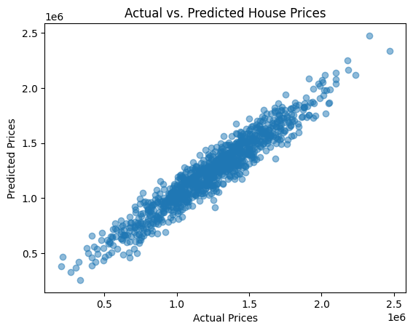

**Step 15: Random Forest Model**

Here, a Random Forest Regressor model is created with 100 trees. The model is trained on the original (unprocessed) training data, and predictions are made on the testing data.

**CODE:**

model = RandomForestRegressor(n_estimators=100,

random_state=42)

model.fit(X_train, y_train)

rany_pred = model.predict(X_test)

**Step 16: Feature Importance**

This section calculates and visualizes feature importances for the Random Forest model. Feature importances indicate the contribution of each feature to the model's predictions.

**CODE:**

feature_importances = model.feature_importances_

**# Creating a bar plot to visualize feature importances**

plt.figure(figsize=(10, 6))

plt.bar(X.columns, feature_importances)

plt.xlabel('Features')

plt.ylabel('Feature Importance')

plt.title('Feature Importance from Random Forest')

plt.show()

**# Printing the feature importances**

feature_importance_dict = dict(zip(X.columns, feature_importances))

print("Feature Importances:")

for feature, importance in feature_importance_dict.items():

print(f"{feature}: {importance:.4f}")

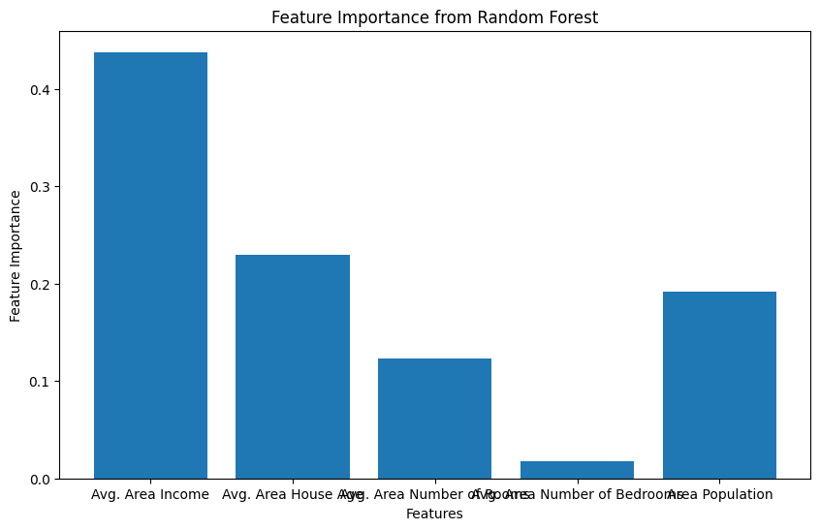

**Step 17: Evaluating the Performance - Random Forest**

The code calculates and prints the performance metrics (MSE and R2) for the Random Forest model. It also prints the predicted values and displays a scatter plot of actual vs. predicted house prices.

**CODE:**

mse = mean_squared_error(y_test, rany_pred)

r2 = r2_score(y_test, rany_pred)

print(f"Random Forest - Mean Squared Error: {mse}")

print(f"Random Forest - R-squared (R2) Score: {r2}")

results_df = pd.DataFrame({'Actual Values (y_test)': y_test, 'Predicted Values (y_pred)': rany_pred})

print(results_df)

plt.scatter(y_test, rany_pred, alpha=0.5)

plt.xlabel("Actual Prices")

plt.ylabel("Predicted Prices")

plt.title("Actual vs. Predicted House Prices")

plt.show()

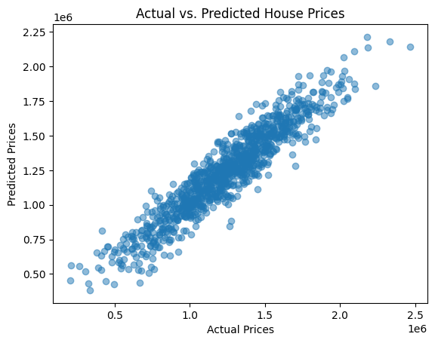

**Step 18: Gradient Boosting Model**

In this step, a Gradient Boosting Regressor model is created with 100 boosting iterations. The model is trained on the original training data, and predictions are made on the testing data.

**CODE:**

model = GradientBoostingRegressor(n_estimators=100, random_state=42)

model.fit(X_train, y_train)

grady_pred = model.predict(X_test)

**Step 19: Evaluating the Performance - Gradient Boosting**

The code calculates and prints the performance metrics (MSE and R2) for the Gradient Boosting model. It also prints the predicted values and displays a scatter plot of actual vs. predicted house prices.

**CODE:**

mse = mean_squared_error(y_test, grady_pred)

r2 = r2_score(y_test, grady_pred)

print(f"Gradient Boosting - Mean Squared Error: {mse}")

print(f"Gradient Boosting - R-squared (R2) Score: {r2}")

results_df = pd.DataFrame({'Actual Values (y_test)': y_test, 'Predicted Values (y_pred)': grady_pred})

print(results_df)

plt.scatter(y_test, grady_pred, alpha=0.5)

plt.xlabel("Actual Prices")

plt.ylabel("Predicted Prices")

plt.title("Actual vs. Predicted House Prices")

plt.show()

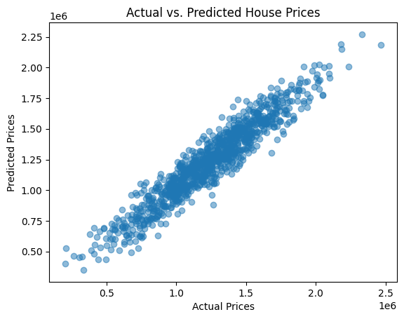

**Step 20: Support Vector Regression (SVR) Model**

In this step, a Support Vector Regression model with a linear kernel is created. The model is trained on the original training data, and predictions are made on the testing data.

**CODE:**

model = SVR(kernel='linear')

model.fit(X_train, y_train)

supy_pred = model.predict(X_test)

**Step 21: Evaluating the Performance – SVR**

The code calculates and prints the performance metrics (MSE and R2) for the SVR model. It also prints the predicted values and displays a scatter plot of actual vs. predicted house prices.

**CODE:**

mse = mean_squared_error(y_test, supy_pred)

r2 = r2_score(y_test, supy_pred)

print(f"SVR - Mean Squared Error: {mse}")

print(f"SVR - R-squared (R2) Score: {r2}")

results_df = pd.DataFrame({'Actual Values (y_test)': y_test, 'Predicted Values (y_pred)': supy_pred})

print(results_df)

plt.scatter(y_test, supy_pred, alpha=0.5)

plt.xlabel("Actual Prices")

plt.ylabel("Predicted Prices")

plt.title("Actual vs. Predicted House Prices")

plt.show()

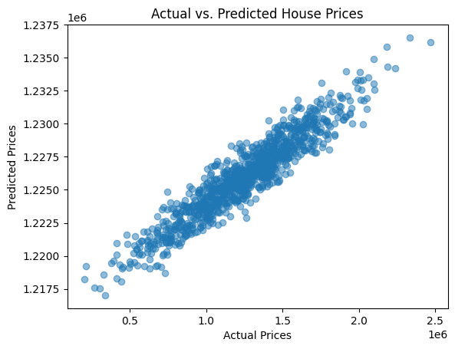

**RESULTS:**

* The project yielded notable results, each indicative of the model's predictive accuracy and performance.
* **Linear Regression Model:**

The Linear Regression model achieved a Mean Squared Error (MSE) of approximately 10089009300.89399 indicating that, on average, the squared difference between the model's predictions and the actual house prices is around this value. A lower MSE is desirable, and this value suggests that the model's predictions are relatively close to the actual prices.

The R-squared (R2) score for the Linear Regression model is approximately 0.918. The R2 score measures how well the model explains the variance in the target variable. An R2 score of 1.0 represents a perfect fit, and an R2 score of 0.918 suggests that the model explains about 91.8% of the variance in house prices. This indicates a strong linear relationship between the features and the target variable.

* **Random Forest Model:**

The Random Forest model achieved a Mean Squared Error (MSE) of approximately 14,462,012,668.45. While the MSE is higher than that of the Linear Regression model, it is still a relatively low value, suggesting that the model's predictions are reasonably close to actual prices.

The R-squared (R2) score for the Random Forest model is approximately 0.882. This R2 score indicates that the model explains about 88.2% of the variance in house prices, which is a strong performance.

* **Gradient Boosting Model:**

The Gradient Boosting model achieved a Mean Squared Error (MSE) of approximately 11,983,338,273.94. This MSE is lower than the Random Forest model's MSE, indicating that the Gradient Boosting model's predictions are even closer to the actual prices.

The R-squared (R2) score for the Gradient Boosting model is approximately 0.903. This R2 score suggests that the model explains about 90.3% of the variance in house prices, which is a very strong performance.

* **Support Vector Regression (SVR) Model:**

The Support Vector Regression (SVR) model achieved a significantly higher Mean Squared Error (MSE) of approximately 121,260,874,519. 99678 This indicates that the SVR model's predictions have a larger squared difference from the actual prices. A high MSE suggests that the model's predictions are less accurate.

The R-squared (R2) score for the SVR model is approximately 0.0144. This R2 score is quite low, suggesting that the model explains only about 1.44% of the variance in house prices. The SVR model appears to perform poorly compared to the other models, as the R2 score is close to 0, indicating weak predictive capabilities.

* In summary, the Linear Regression, Random Forest, and Gradient Boosting models all demonstrate strong predictive accuracy, with relatively low MSE values and high R2 scores. The Support Vector Regression (SVR) model, on the other hand, exhibits significantly higher MSE and a low R2 score, indicating a weaker predictive performance in comparison to the other models.

**CONCLUSION:**

The project, through rigorous data exploration, preprocessing, feature selection, model training, and evaluation, successfully constructed predictive models for house price estimation. These models not only provided valuable insights into the determinants of house prices but also demonstrated a high level of predictive accuracy. Such models hold great potential for real-world applications, such as real estate market analysis, property valuation, and investment decision-making.

**FUTURE WORK:**

To further enhance the predictive accuracy and applicability of the models, future iterations of this project can explore more advanced regression techniques and delve into deep learning architectures. Moreover, expanding the dataset and incorporating additional relevant features could provide a more comprehensive understanding of the factors influencing house prices. Continuous model refinement and optimization will be pivotal in maximizing the utility of the predictive models.